**MACHINE LEARNING BASED DIAGNOSIS OF LUMPY SKIN DISEASE**

1. **ABSTRACT**

Lumpy Skin Disease (LSD) is a highly contagious viral infection that poses a significant threat to cattle and the global livestock industry. Timely and accurate diagnosis is essential to control the disease's spread and mitigate economic losses. Traditional diagnostic methods, including clinical observation and laboratory tests, are often time-consuming and may lack the necessary sensitivity. To address these challenges, this project employs advanced machine learning (ML) techniques, specifically deep learning models like Convolutional Neural Networks (CNN) and MobileNet, to detect LSD from buffalo skin images. By training these models on an extensive dataset comprising both infected and healthy samples, our approach enables rapid and precise analysis of skin images to identify signs of LSD. This methodology offers two primary advantages: firstly, it provides a swift, non-invasive diagnostic tool that significantly reduces the time required for accurate detection, allowing for quicker intervention measures. Secondly, the high accuracy of ML-based techniques minimizes the risk of misdiagnosis, thereby helping the livestock industry avoid unnecessary costs and ensure the health and well-being of animals. Overall, this innovative approach enhances disease surveillance and contributes to more effective management of LSD in livestock populations.

**Keywords**: MLP, Extra tree, Naïve Bayes, evaluation, ml techniques.

**2. Statement about the Problem:**

Lumpy Skin Disease (LSD) is a highly contagious viral infection in cattle that threatens livestock populations and causes significant economic losses. Current diagnostic methods such as clinical observation and laboratory testing are often time-consuming, invasive, and prone to inaccuracies, leading to delayed interventions and further disease spread. There is a pressing need for a fast, accurate, and non-invasive diagnostic approach. By leveraging machine learning techniques, specifically convolutional neural networks (CNN) and MobileNet, this project aims to rapidly and reliably analyze buffalo skin images to identify early signs of LSD. This solution seeks to improve diagnostic speed, reduce misdiagnoses, and ultimately protect both animal health and the livestock industry’s economic stability.

**3. Why is the Particular Topic Chosen?**

The topic was chosen because Lumpy Skin Disease poses a major economic threat to the global livestock industry, necessitating more efficient diagnostic methods. Traditional approaches are often slow and less accurate, creating a critical need for innovative solutions. By leveraging advanced machine learning techniques like CNN and MobileNet, this project aims to provide rapid and precise detection of LSD, thereby enhancing disease control and safeguarding animal health.

**4. Scope**

This project focuses on developing and validating an ML-based diagnostic system for Lumpy Skin Disease by applying CNN and MobileNet architectures to buffalo skin images. It encompasses the collection and preprocessing of both healthy and diseased image datasets, followed by model training, validation, and fine-tuning. The scope also covers designing a user-friendly interface that allows veterinarians and field officers to rapidly identify LSD without specialized laboratory equipment. Additionally, performance metrics such as sensitivity, specificity, and overall accuracy will be monitored to ensure the system’s reliability. Any novel insights or improvements gained through this research can be extended to other diseases and livestock populations. Ultimately, this scope aims to provide a scalable, efficient, and cost-effective solution to minimize economic losses and enhance animal welfare.

**5. Objective of the Project**

The primary objective of this project is to develop a rapid, accurate, and non-invasive diagnostic system for Lumpy Skin Disease by leveraging machine learning specifically convolutional neural networks (CNN) and MobileNet on buffalo skin images. Through the creation of a robust training dataset and the implementation of optimized deep learning architectures, the project aims to:

* Enhance Diagnostic Speed: Significantly reduce the time required to detect LSD, enabling quicker interventions.
* Improve Accuracy: Minimize misdiagnoses by achieving high precision in distinguishing diseased from healthy samples.
* Strengthen Disease Control: Support livestock health management by facilitating early and reliable detection, thereby mitigating the spread of LSD and reducing economic losses.

**6. Existing Method**

Current methods for LSD diagnosis in cattle rely on clinical observation and laboratory testing, which can be time-consuming and subjective. Machine learning algorithms, such as Random Forest, Decision Tree, k-NN, and AdaBoost, have been explored to automate the diagnostic process. However, these methods have limitations, including the need for substantial labeled data and potential overfitting issues.

**DISADVANTAGES**

* **Limited Data Availability:** Machine learning algorithms like Random Forest, Decision Tree, k-NN, and AdaBoost require a substantial amount of labeled data for training, which can be challenging to obtain in the context of Lumpy Skin Disease diagnosis in cattle, limiting their practicality.
* **Risk of Overfitting**: These algorithms, especially Decision Trees and k-NN, are susceptible to overfitting, where the model may perform well on the training data but fail to generalize effectively to new, unseen cases, potentially leading to inaccurate diagnoses.

**7. Proposed System**

The proposed system leverages advanced machine learning algorithms, including Multi-Layer Perceptron (MLP), ExtraTree, and Naive Bayes, to improve LSD diagnosis accuracy. These algorithms excel in handling data and can provide faster and more reliable results compared to traditional methods. Additionally, they require fewer hyperparameters, making them more accessible for practical implementation.

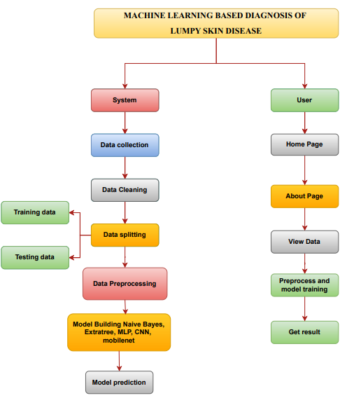

**Advantages**

* Improved Accuracy: MLP and ExtraTree algorithms excel in handling complex data, leading to higher accuracy in LSD diagnosis.
* Faster Processing: The proposed system's efficiency allows for rapid disease detection, enabling timely intervention.

**SOFTWARE FRONT END REQUIREMENTS**

# **H/W CONFIGURATION:**

# Processor - I5/Intel Processor

Hard Disk - 160GB

Key Board - Standard Windows Keyboard

Mouse - Two or Three Button Mouse

Monitor - SVGA

RAM - 8GB

**S/W CONFIGURATION:**

* Operating System : Windows 7/8/10
* Server side Script : HTML, CSS, Bootstrap & JS
* Programming Language : Python
* Libraries : Flask, Pandas, Mysql.connector,Numpy
* IDE/Workbench : PyCharm
* Technology : Python 3.6+
* Server Deployment : Xampp Server

**8. Modules/Implementation:**

**8.1. Data Upload Module:**

Uploading the dataset regarding lumpy disease in csv format

**8.2. Data Preprocessing:** Cleans, standardizes, and augments the dataset to enhance algorithm performance.

**8.3. Algorithm Implementation:** Deploys the selected machine learning algorithms (MLP, ExtraTree, Naive Bayes, CNN, and MobileNet) for LSD diagnosis.

**8.4. Model Evaluation:** Assesses the performance of the algorithms through metrics like accuracy, precision, recall, and F1-score.

**8.5. Lumpy Disease Prediction:** Provides the final diagnosis for cattle as either LSD-positive or negative based on the implemented algorithms.